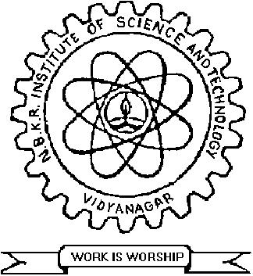 | NBKR INSTITUTE OF SCIENCE & TECHNOLOGY :: VIDYANAGAR  LESSON PLAN FORM  Form no: TEA/04/00

Department : ELECTRICAL & ELECTRONICS ENGINEERING – B Section
Academic Year : 2016-2017
Class : II B.Tech. II Semester
Subject : PULSE AND DIGITAL CIRCUITS
Faculty Name : Sri M Raveendra

Sl. No. |  | Description of Topic | No. of Periods |  | Dates
 |  |  | Planned | Taken
 |  | UNIT – I
 |  | Wave shaping circuits:
1 |  | Types of waveforms | 2
2 |  | Characteristics of pulse waveforms | 2
3 |  | RC low pass and high pass circuits | 3
4 |  | rise time, tilt | 2
5 |  | Diode as a switch | 1
6 |  | Diode clipper and clamper circuits | 3
 |  | UNIT – II
 |  | Multivibrators:
1. |  | BJT switch and switching times | 3
2. |  | Bistable multi-vibrator using BJT | 2
3. |  | Mono-stable multi-vibrator using BJT | 1
4. |  | Astable multi-vibrator using BJT | 1
5. |  | Schmitt-trigger | 2
6. |  | triggering methods | 1
 | UNIT – III
 |  | Time Base circuits:
1. |  | RC sweep circuits | 1
2. |  | constant current, Miller and Bootstrap time base generators using BJT’s | 2
3. |  | UJT relaxation oscillators | 3
4. |  | sampling gates | 1

NBKR INSTITUTE OF SCIENCE & TECHNOLOGY :: VIDYANAGAR
LESSON PLAN FORM
Form no: TEA/04/00

Sl. No. | Description of Topic | No. of Periods |  |  | Dates
 |  | Planned | Taken
 | UNIT – IV
 | MOS Transistor:
1. | MOS and CMOS Structure | 2
2. | Operation (enhancement and depletion mode) | 2
3. | I/V Characteristics | 1
4. | Second Order effects - MOS Device capacitance | 1
5. | Small signal model | 1
 | UNIT – V
 | Power Amplifiers: | 2
1. | Class-A amplifier | 2
2. | Transformer coupled Class-A amplifier | 1
3. | Class-B Push-pull amplifier | 2
4. | Complementary Class-B push-pull amplifier
 | Tuned amplifiers: | 1
5. | Introduction, Q-factor | 2
6. | small signal tuned amplifiers | 2
7. | effect of cascading single tuned amplifier on bandwidth | 2
8. | stagger tuned amplifiers
 | Total : | 53

Date: Faculty Signature

HOD Signature

